Lab # Kernel Debugging — Assessment Worksheet

**Course Name and Number: IAM302**

**Student Name: Tran Thanh Tuan**

**Student Id: SE161095**

**Instructor Name: Vu Duc Ly**

## **View Information of A Driver Using Windbg**

***Using Windbg***

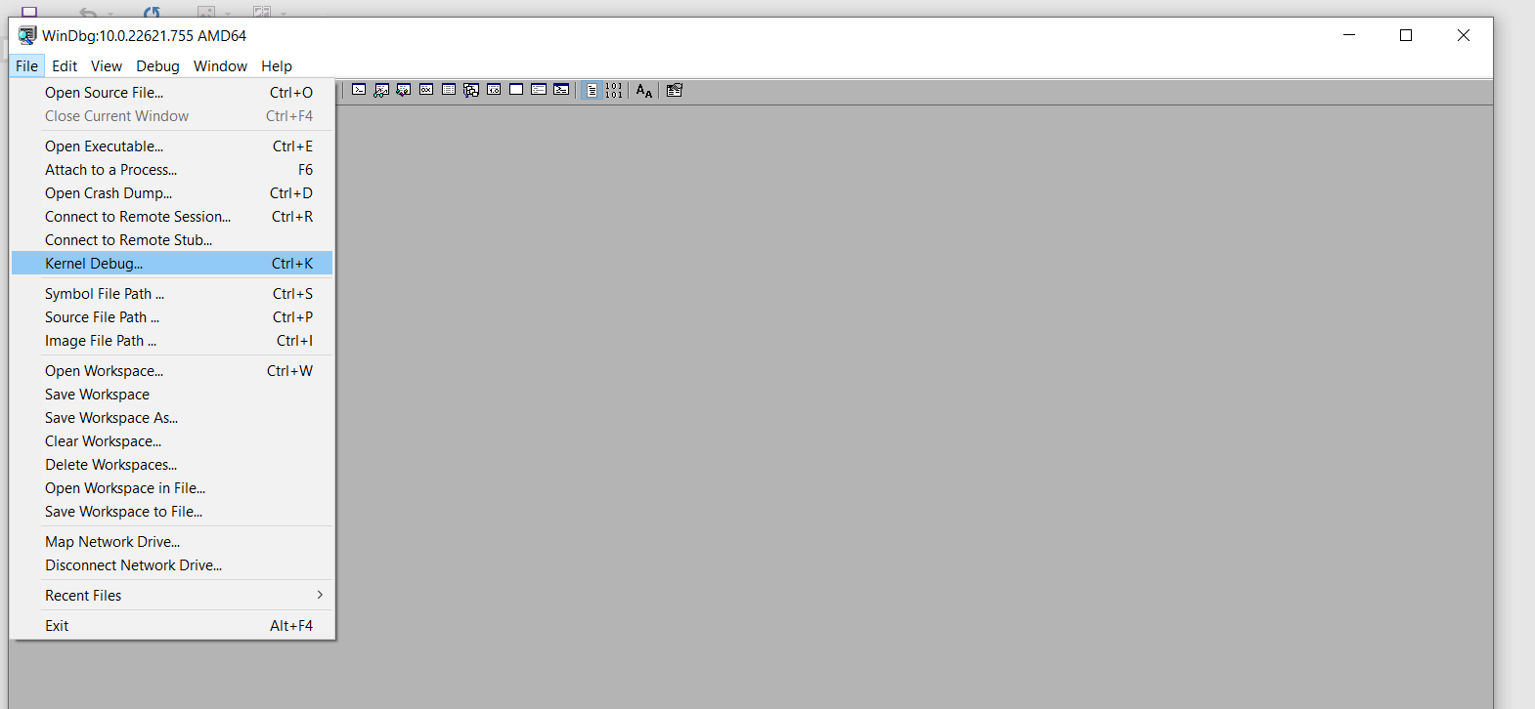

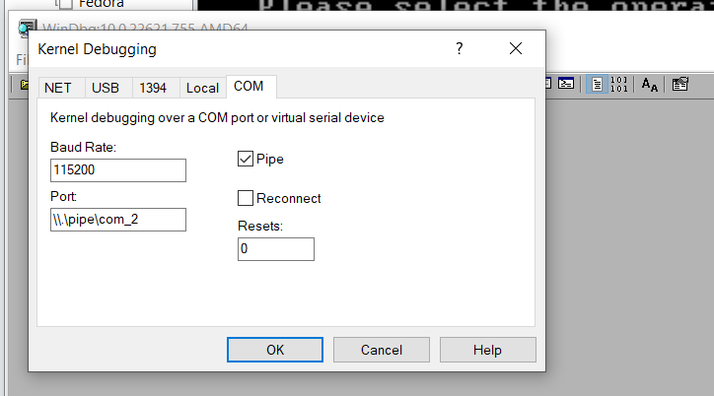

***Booting the VM***

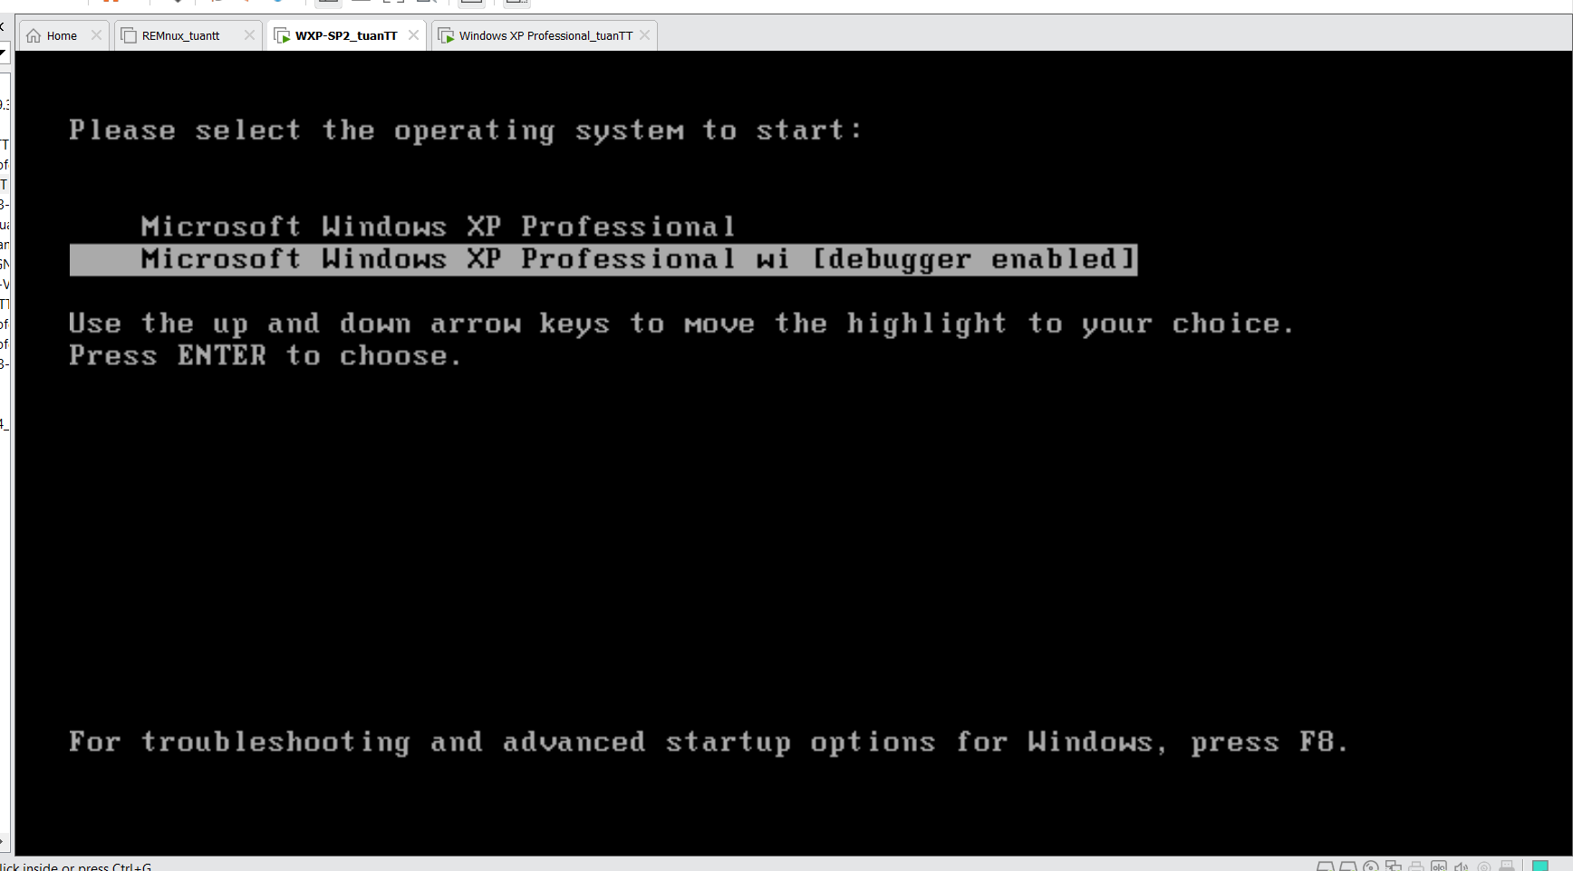

***Loading Driver***

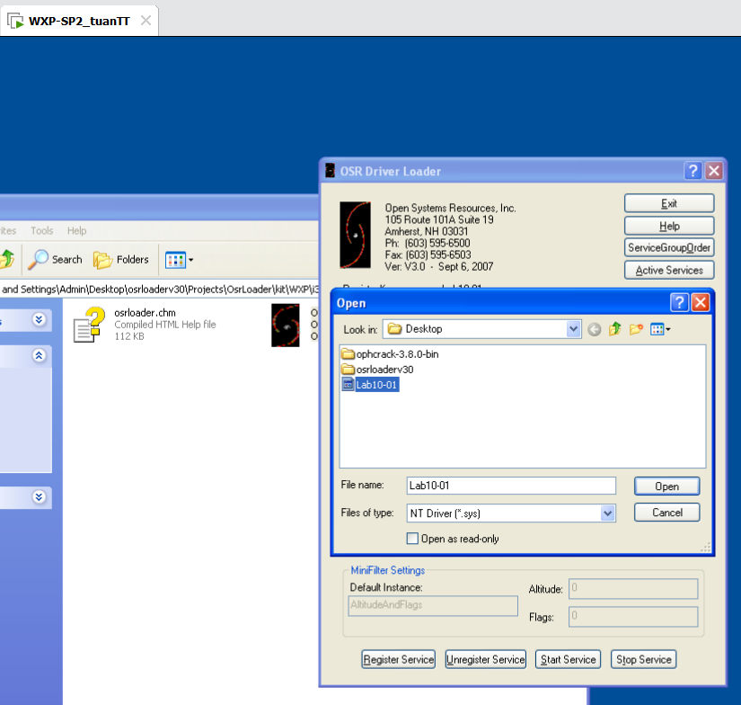

***Result***

* **Get the driver object**

Using !drvobj Lab10-01

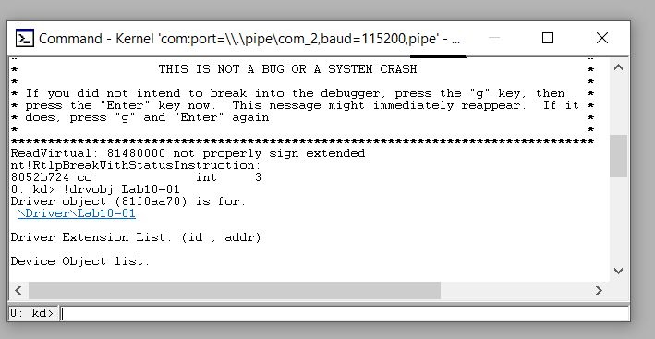

* **View the driver object**

Using dt command: dt _DRIVER_OBJECT 8263b418

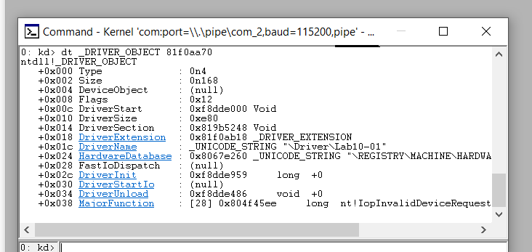

* **Set a break point when the driver is unloaded**

Using bp 0xf8b4a486

